Location:

Conference talks will take place in Grant Recital Hall (105 Benevolent Street, in between Hope Street and Cooke Street). Coffee breaks will occur in the Grant lobby.

The closing reception will occur in the adjoining Fulton Rehearsal Hall.

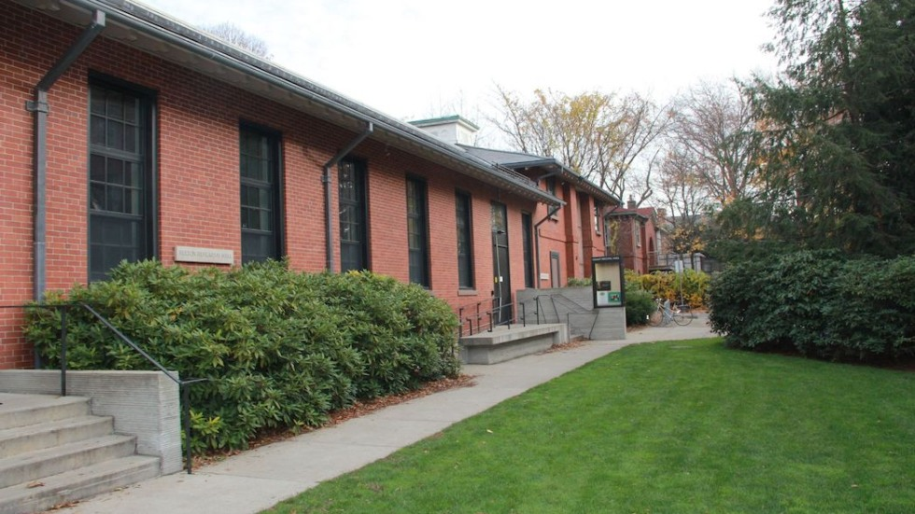
(exterior of Grant and Fulton)

Getting to Brown:

Driving:

The easiest way to get to Grant Recital Hall is to take I-95 to Providence. Take exit 36A to I-195, then take Exit 2A (the first exit) to Gano Street. Turn left at the light, then continue for about a half-mile before turning left on Power Street, which will take you close to Grant and the other Music Department buildings.

There is plenty of free street parking in the area, though the streets immediately closest to Grant have a 2-hour limit and tend to fill up at the beginning of the day on weekdays. If you are able to walk a few blocks, there is no time limit for parking on or east of Governor Street (2 blocks east of Grant).

If parking east of the music building, Grant is most easily accessed through the parking lot next to the Orwig Music Building (1 Young Orchard Ave)---Grant is on the other side of the lot.

Public transit:

If using public transportation, take Amtrak or the MBTA Commuter Rail to Providence Station. Walk south on Exchange Street for about 0.8 miles to Kennedy Plaza (the main bus hub; you can also take the 58, 51, 54, or 72 buses for 1 stop). Then take the 32, 33, 34, or 40 RIPTA bus to the “Waterman before Hope” stop (3 stops).

After getting off the bus, turn right on Hope Street and walk a few blocks. Once you pass Benevolent St., there will be a small entry path on the east side of the street, through which you can access Fulton and Grant.

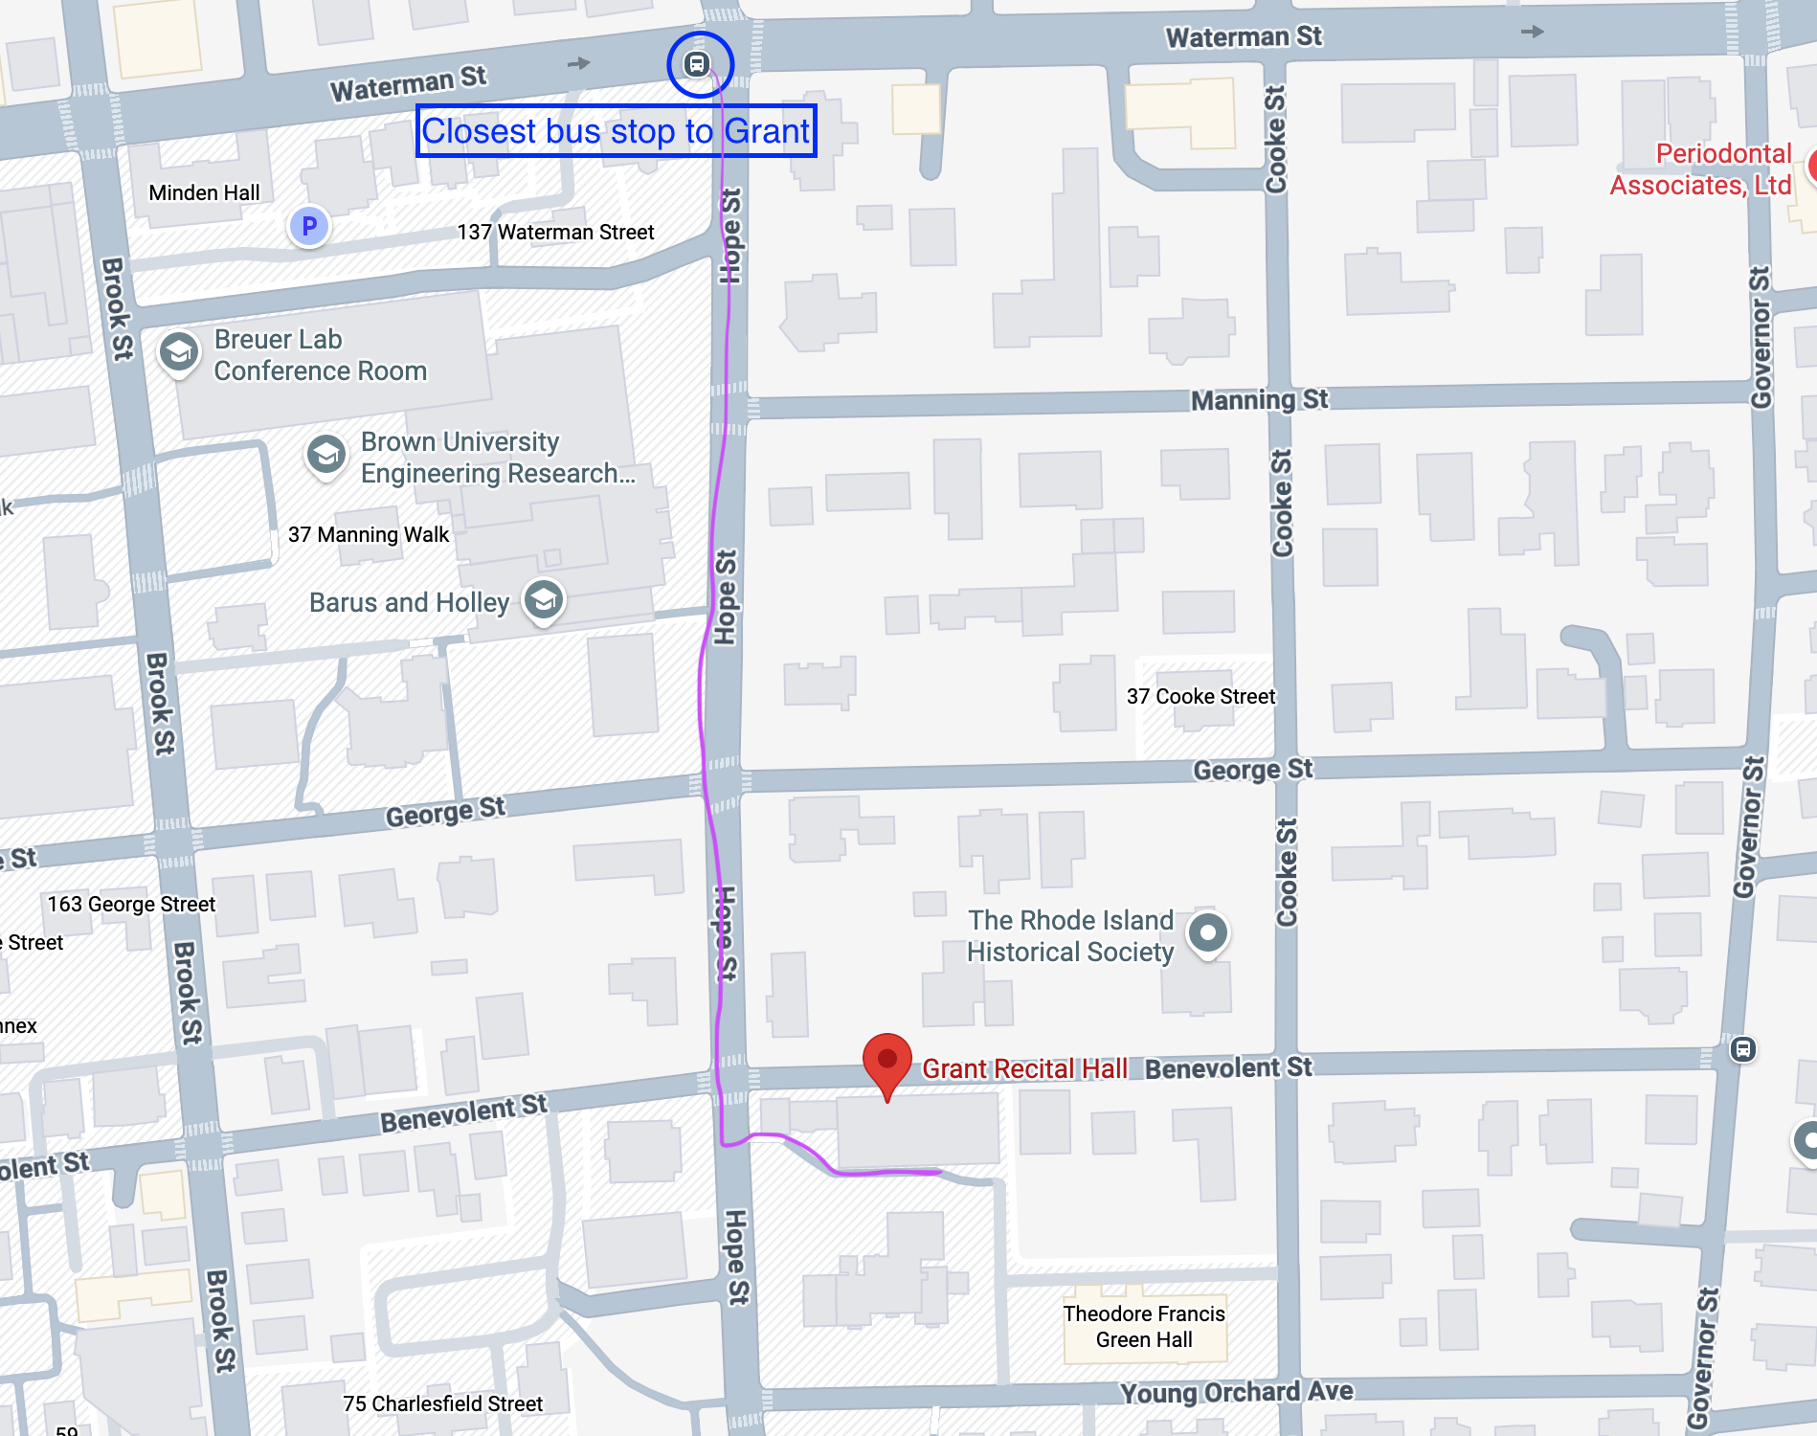

Air:

If flying to Providence, the closest airport is Rhode Island T.F. Green International Airport (in Warwick, RI; about a 15-20 minute drive from campus).

The closest major hub is Boston Logan International Airport, which is accessible to/from Providence via the MBTA commuter rail or Amtrak. Take the Silver Line Bus to South Station, then a train to downtown Providence (about 1 hour between South Station and Providence).

Dining:

The closest restaurants to Grant Recital Hall are:

- Hazel Origin Coffee (coffee/tea, pastries, sandwiches; closes at 6 PM): 250 Brook Street
- 12 Dumplings and Hot Pot: 83-85 Benevolent Street
- Champa Thai and Lao Restaurant: 93 Hope Street
- Tea in Sahara (Moroccan): 69 Governor Street
- Persimmon (New American, dinner only): 99 Hope Street
- Dolores (Mexican, dinner only): 100 Hope Street

Within a ~15 minute walk of Grant, you can also find restaurants on Thayer Street (a bit north of the music building), Ives Street (a few blocks southwest), and Wickenden Street (further south).

Good casual restaurants include:

Thayer Street:

- East Side Pockets (Middle Eastern): 278 Thayer Street
- Bagel Gourmet (Bagels, sandwiches, Mexican): 205 Meeting Street
- Meeting Street Cafe: 220 Meeting Street
- Kabob and Curry: 261 Thayer Street
- Antonio’s Pizza: 256 Thayer Street
- Al Shami (Middle Eastern, limited seating): 225 Thayer Street
- Heng Thai: 165 Angell Street

Ives Street:

- Dune Brothers (seafood): 170 Ives Street
- Bee’s Thai Cuisine: 167 Ives Street
- Tallulah’s Taqueria: 146 Ives Street
- Aleppo Sweets (Middle Eastern): 107 Ives Street

Wickenden Street:

- Pizza Marvin: 468 Wickenden Street
- Rong Chic (Chinese): 388 Wickenden Street
- Jahunger (Uyghur): 333 Wickenden Street
- Fellini Pizzeria: 166 Wickenden Street

Lodging:

The closest hotel to Grant Recital Hall is the Hilton Garden Inn: 220 India St, Providence, RI 02903 (0.8 miles away, about an 18 minute walk or 5 minute drive from Orwig).

You could also stay at a hotel downtown and take the RIPTA bus to get to Brown (see the “Public Transit” section of “Getting to Brown” for more information on local transportation).

Downtown hotel options include:
- Graduate by Hilton (11 Dorrance St)
- Courtyard by Marriott (32 Exchange Terrace)
- Omni Providence (1 W Exchange St
- Residence Inn by Marriott (100 Sabin St)
- Neptune (122 Fountain St)
- Hampton Inn (58 Weybosset St)
- Hilton Providence (21 Atwells Ave)

